EGYPTIAN FLIGHT INSPECTION
AIRCRAFT

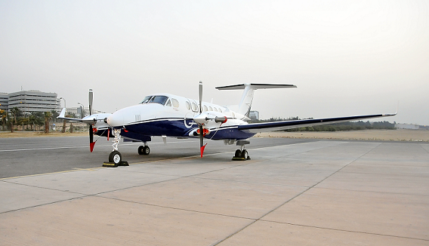

Egyptian Smart aviation and ANSP (NANSC) have already introduced one of the most advanced Automatic Flight Inspection System (AFIS) for radio ground based navigation systems, complete integrated aboard the Navaids calibration aircraft model Beechcraft King Air 350i. This service also covers the Ground Support Equipment (GSE), the portable GPS for aviation and ground positioning use and the DGPS ground reference station for the AFIS. Most of equipments are European manufacturer with international recognition, and can provide unique capabilities for advanced calibration cabability with special consideration of compliance with both European (EASA) and US (FAA) regulations, equipment compatibility with neighboring countries, and highest levels of product support.
The Automatic Flight Inspection System with regard to obtain a maximum of efficiency, reliability and easy system operation.

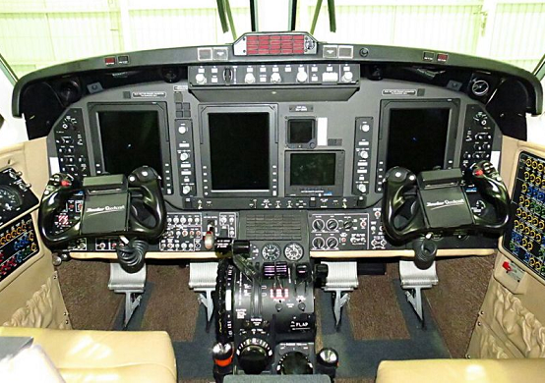

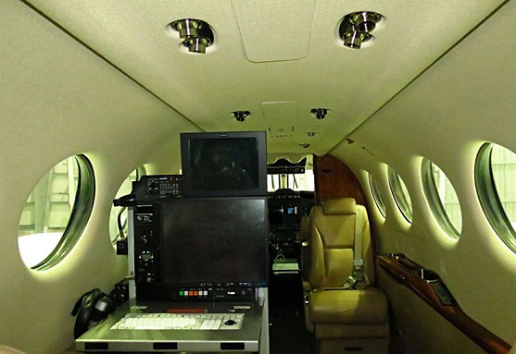

CAPABLITIES OF FLIGHT INSPECTION SYSTEM

The Flight Inspection System is an automatic system, AD-AFIS-260, and configured to possess the following capabilities,

- Instrument Landing System, ILS CAT I, II, & III

- ILS markers, MKR.

- VHF Omni Directional Radio Range, CVOR / DVOR

- Distance Measuring Equipment, DME,

- Non Directional Beacon, NDB

- Direction Finding, VDF and UDF,

- Visual Approach Position Indicator, PAPI, VASI,

- Precision Approach Radar, PAR,

- Primary and Secondary Surveillance Radar, PSR / SSR with MODE A/C/S option.

- Area Navigation, RNAV, RNP based on both GNSS and Ground Navigational Aids.

- Standard Instrument Procedures, SID / STAR.

The AFIS is capable to perform multiple calibration tasks simultaneously, such as structure measurement for Glide Slope and Localizer together with Markers, DME and NDB during one approach. The AFIS also provides the ability to calibrate two en-route stations simultaneously while flying along one Radial, the so called dual radial procedure. ie one single radial flight, two VOR / DMEs can be calibrated at the same time and so on.

Flight inspectors as well as pilots, mix of certified German and Egyptian staff, are experienced to achieve a high level of efficiency.

For more details please contact :

